

|  |  |  |  |  |  |  |  |  |
| --- | --- | --- | --- | --- | --- | --- | --- | --- |
| A:1PC | B:1PC | | C:1PC | D:1PC | E:2PCS | F:2PCS | G:1PC | |
|  |  | |  |  |  |  |  | |
| H:2PCS | I:8PCS | J:4PCS | K:4PCS | L:4PCS | M:1PC | N:1PC | O:4PCS | P:2PC |
| M6 | M6*12 | M8 | M8 NUT | TAPPINGSCREW | 4MM ALLEN KEY | 5MM ALLEN KEY | M6*16 | M4*40 |

**SMLFT (S650, S1000, S1300)**

**TV LIFT INSTRUCTIONS**

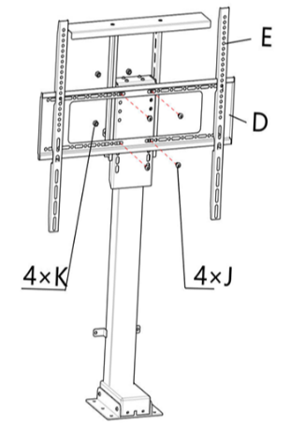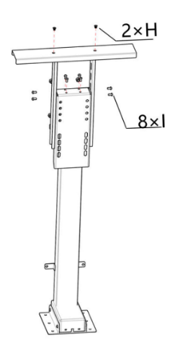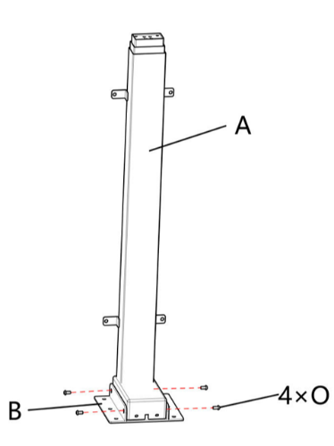Step 1. Step 2. Step 3.

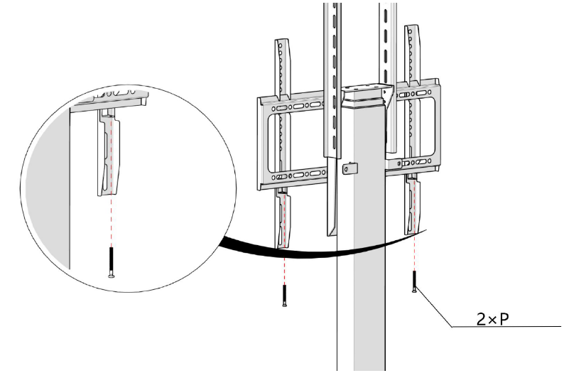Step 4.

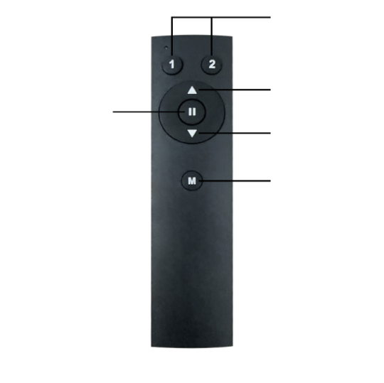

Height Memory Presets

Stop

Up(automatic)

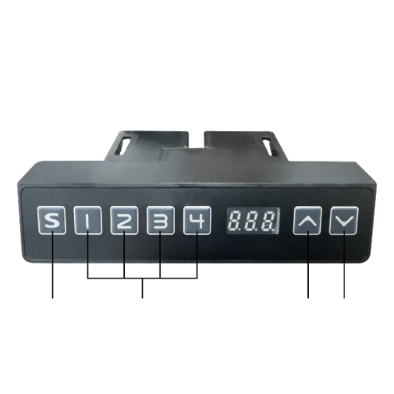

Down(automatic)

Set memory

Memory

Set

Height Presets

Up

Down

**Warning**: Please measure all relevant components before installation to avoid any interference or collisions

## Reset

Reset the TV lift unit after installation using the following steps:

1. Press the down button on the control panel for 5 seconds until the screen shows ‘RST’.
2. Keep pressing the down button until the column has gone down to its lowest height and then bring it back up a tiny amount. Please do not release the down button until the ‘RST’ disappears off the display.

When the ‘RST’ has disappeared, the setup process has finished.

Note: if the screen shows ‘RST’ during normal operation, please follow step 2 to reset the lift.

## Set memory height

Once the TV Lift unit is installed we suggest setting the desired height using the memory functions.

1. Operate the TV lift to the desired height that you want to set the memory function to.
2. Press button ‘S’ on the handset or ‘M’ on the remote controller for 3 seconds till the screen shows ‘SET’
3. Press a number (e.g. 1 or 2 on the remote or 1,2,3 or 4 on the lift control panel) where you want to save the preset. (within 3 seconds after the screen shows ’SET’)
4. The preset height is stored when the screen shows the ’s-number’. (e.g. ‘ S-1’)

## Error

If the screen shows ‘ER1’, the cables are probably not connected correctly. Please check and reconnect all cables.

After re-connecting the cables, press the down button for 3 seconds and follow the above reset steps.

## Pairing remote controller

If the remote control is not working, please follow the below steps:

1. The pairing window time is 3 seconds after the system is powered on. The end of the pairing window period is identified by a single beep
2. During the 3 second pairing window, press & hold the "up" button of the remote control, wait for 4 long beeps and 3 short beeps to signal that pairing has been completed
3. After the pairing completion confirmation beeps, release the "up" button
4. The lift control system will now recognize the remote control.

**Note:** If during normal operation the lift encounters a sudden change in load, the controller will retract the lift in order to prevent damage to the unit.